How we set up our database:

For our database we choose to use MySQL, we choose to use this because of reliability, performance, scalability, and ease of use.

We saw this as crucial for allowing all members to be able to easily download and access the database. [This is the link we used to download MySQL](https://dev.mysql.com/downloads/installer/). It offers extensive help if there are problems downloading and installing with plenty of helpful videos online for troubleshooting. We were able to use these to make sure we had a consistent setup throughout our multiple locations and devices.

We then created a “CreateTables” SQL file to store the script for creating the tables for the database, then we went ahead and copied in the create table DDL statements that we created in Project Part 4 into it.

This worked seamlessly with the exception of a couple of errors throughout that after some quick adjustments made sure it was compatible with MySQL these are covered more in the problem section.

After this was complete we uploaded a script to the github which allowed us to be able to launch the database while creating all of the tables and populate the tables using our CSV’s with all of the data needed for each table.

Where we got our data and how we imported it:

We went through a list of the most popular books noting their titles and adding a couple of our own, afterwards [we went to the abebooks](https://www.abebooks.com/) and looked up these books filling out the year, publisher, and ISBN into a CSV file, afterwards we used load infile which we saw as an [example from stack overflow](https://stackoverflow.com/questions/3635166/how-do-i-import-csv-file-into-a-mysql-table) link to load these CSV files into our table.

After adjusting it to fit our needs we went ahead and got the data imported into our table. We used AI to generate a list of the most popular movies/tv shows for digital media and magazines. Then used the same process to load these in.

Additionally for clients [we used mockaroo to randomly generate](https://mockaroo.com/) a list of emails/names and then wrote a python script to fill out the other columns in our table randomly.

How we tested our database and the results:

For the query testing we ran around 20 different queries testing each of the basic and advanced queries that were given in the project description while adding a few additional queries to test edge cases and specific tables and data in our database.

**Reports:**

Monthly Summary Report- Running the report as a View and calling the view produces this data here, it shows what month we are checking which is December and how many items were borrowed in December,total fees collected,most popular items, and then is broken down by client types.

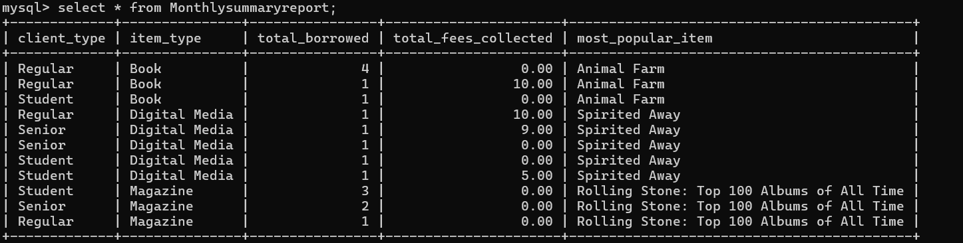

Client Activity Report- Running the report as a View and calling the view produces this data here, producing an individual report for each client showing their borrowing history, outstanding fees.

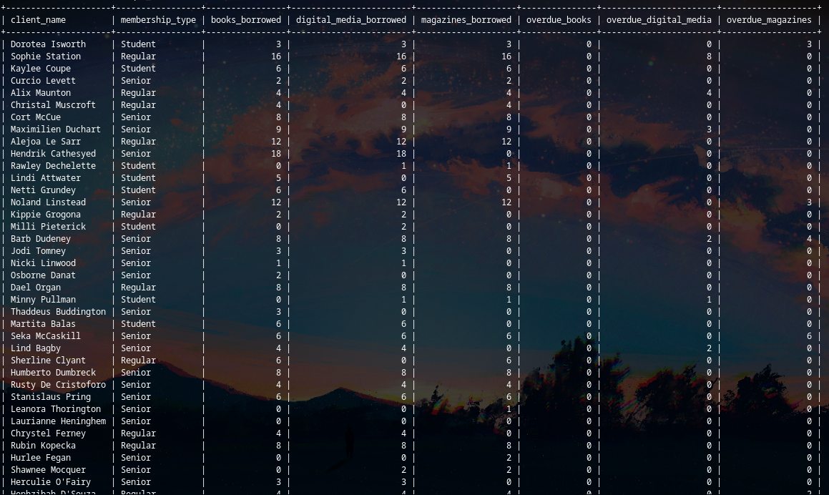

Inventory Report-Running the report as a View and calling the view produces this data here, list all items, their current availability status..

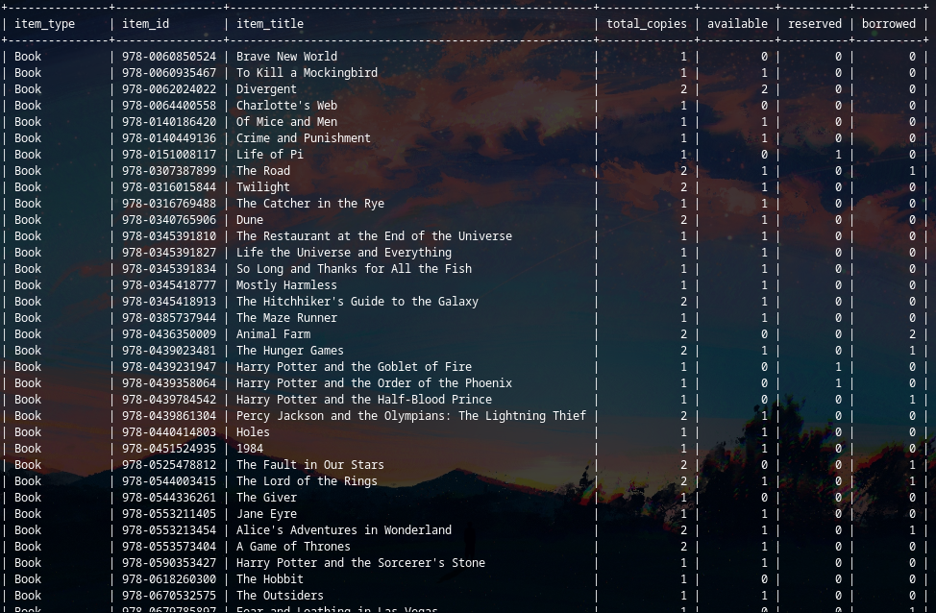

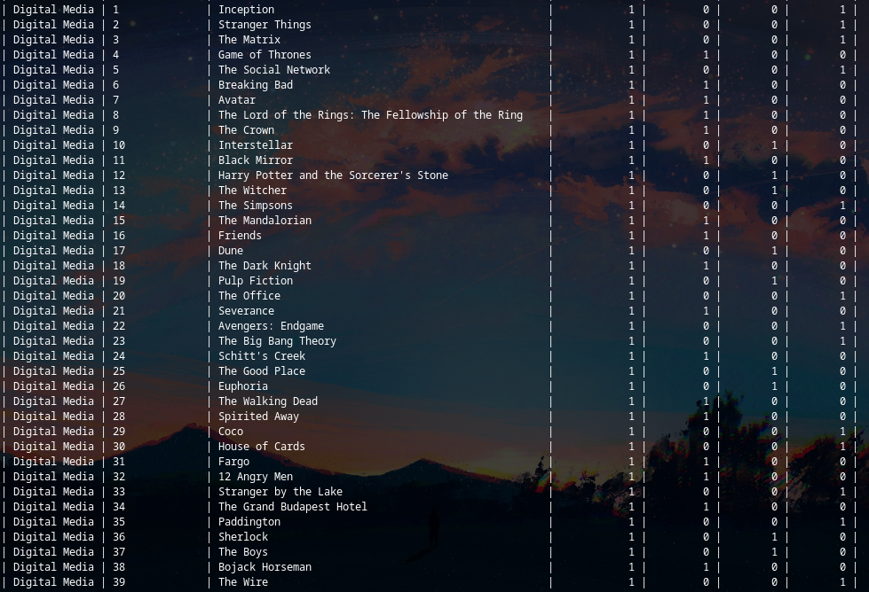

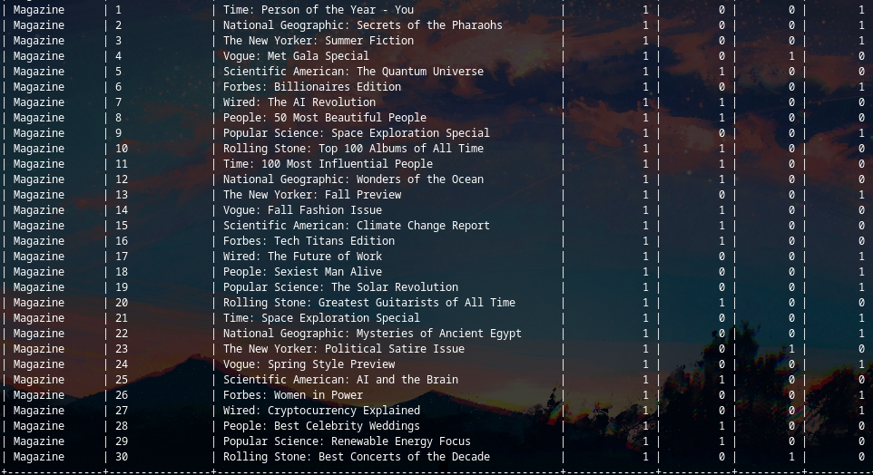

These are some snippets due to the sheer size

Overdue Items Report- Running the report as a View and calling the view produces this data here, generating a report listing all overdue items, the client responsible.

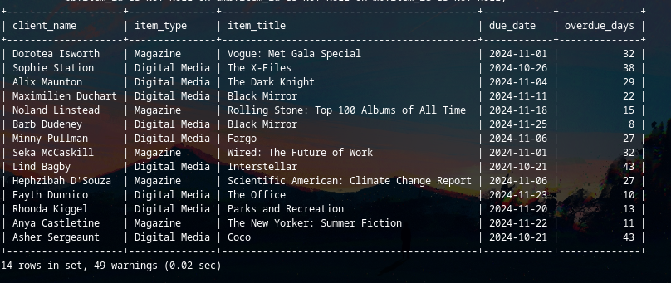

Financial Report-Running the report as a View and calling the view produces this data here, summarizing the library’s revenue from fees, showing the breakdown by membership type and item category.

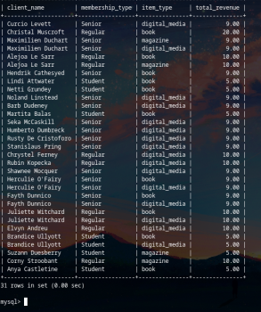

**User interfaces:**

General- When the user clicks run on the program it prompts them for an option of what to do, at this point the user can select between queries/report/accessing the client interface and the staff interface. If the user selects Queries it loads in the following sql script file with each script separated into its own value. the user then selects a script by a number and then it runs the following query. If the user instead selects the view it allows then to select between a list of views and then the program runs/outputs that view to the console

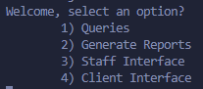

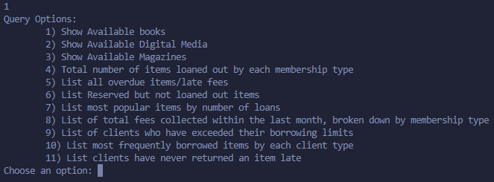

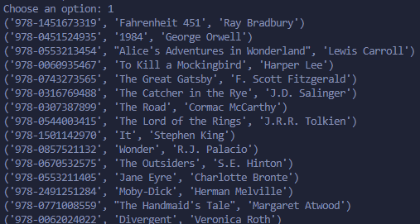

Library Staff- If the user uses the library staff interface it will let them check out items, process returns, add new items, and manage client accounts. It does this through selecting/inserting into the corresponding tables using the same user-friendly environment that queries/reports used. For example, a teacher wants to check out a book. Initially it would prompt them what they want to do and then after they select check out then books after this it asks for the client id of who is checking it out and then the ISBN and borrow date it is being checked out. After these are obtained it goes through and updates the corresponding tables to make sure it is updated in all spots and then it prints a message letting the teacher know that the book was checked out to the user.

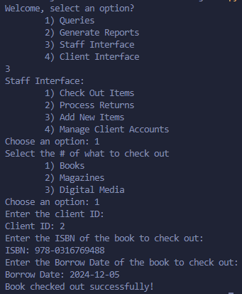

Clients- For client interface it allows clients to searching for available media, reserving items, checking loan status, and viewing outstanding fees. It does this in the same way as the others with the user-friendly interface. For searching the catalog it asks the user for which item they want to search then uses a select statement to find only available items. For reserving it prompts the user for the item they want to reserve and afterwards updates the status of that item to reserved to let the librarians know that the item was reserved. For checking loan status it unions all the borrowing tables only where client id is equal to the users and the return date hasn’t been marked implying a non-returned item. It then goes through each of these items 1 by 1 printing it to the console letting the user know what loans are out. Finally for the outstanding fees it first checks that the user account actually exists and is active letting the user know if that isnt the case, afterwards it selects all fees corresponding to the user and then prints them off 1 by 1 to the user.

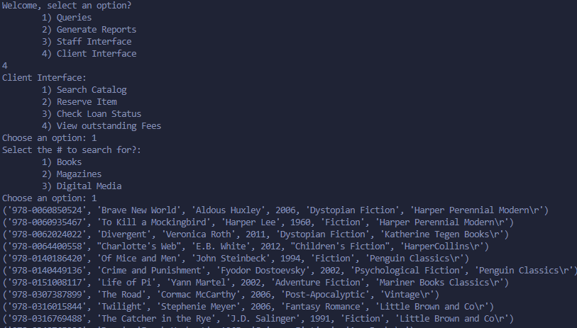

Queries:

1. Show Available Books

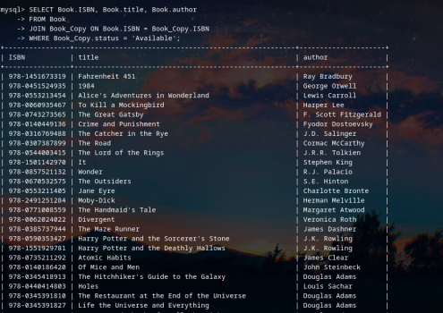

1. Show Available Digital Media

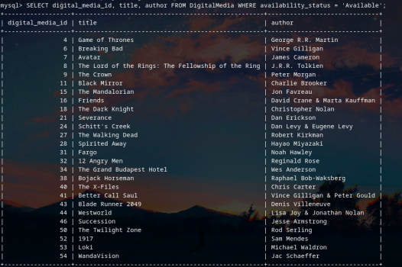

1. Show Available Magazines

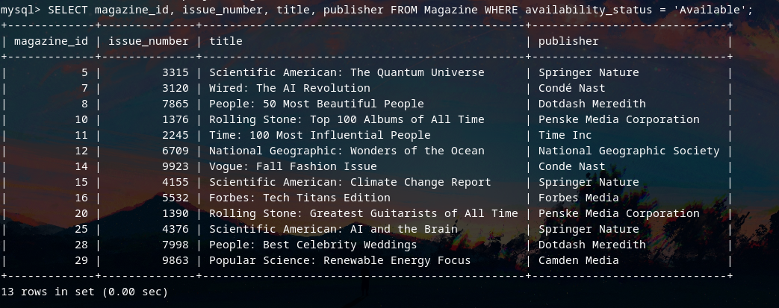

1. Find total Number of items loaned out by each membership type

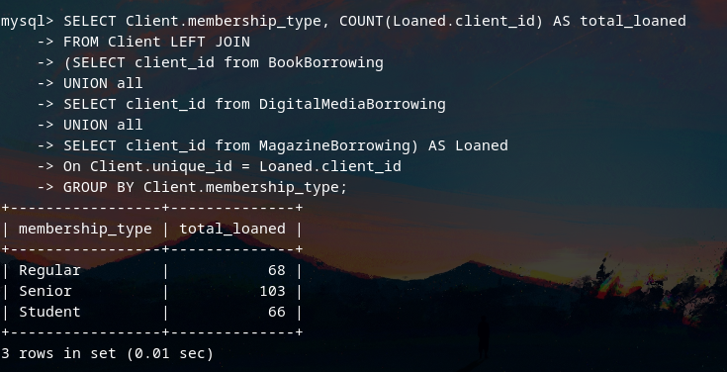

1. List all overdue items/late fees

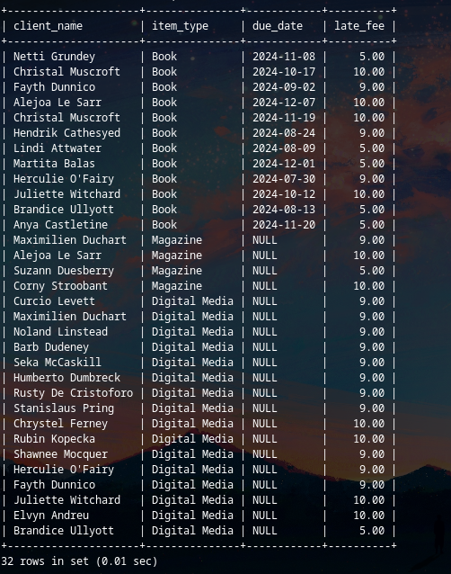

1. List Reserved but not loaned out items

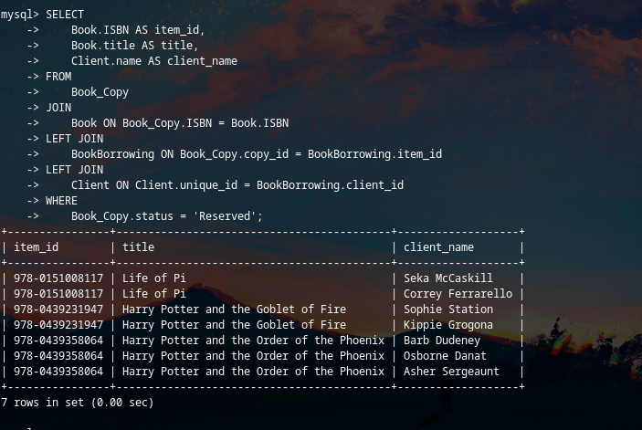

1. List most popular items by number of loans

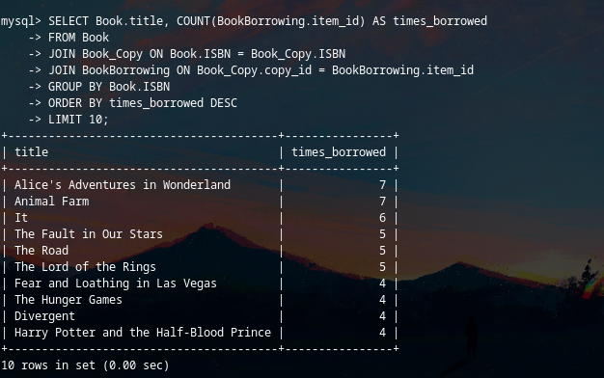

1. Generate a report of total fees collected within the last month, broken down by membership type.

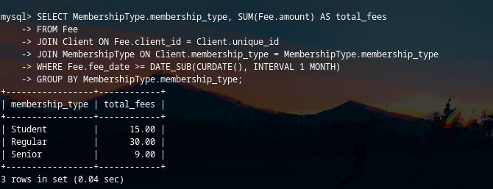

1. Produce a list of clients who are at their borrowing limits.

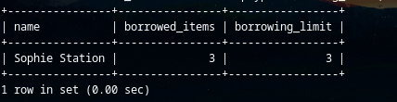

1. List the top 3 borrowed items for each membership type and item type

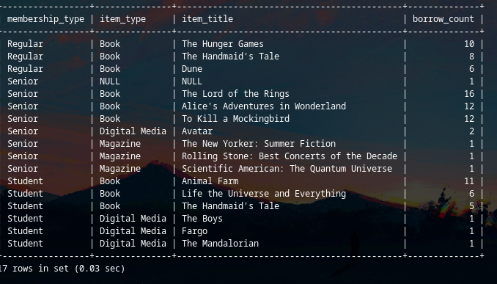

1. Find out which clients have never returned an item late

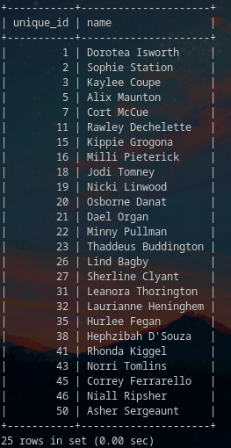

Problems we faced and how we solved them:

Our first problem we ran into was finding data that would properly fit our database as the [majority of datasets didn’t include a lot of the bits we needed or was really small in comparison](https://www.kaggle.com/datasets/bimalgajera/library-books). This led to us hand making a lot of the data and generating some of the other bits randomly as well as described in the “How we got our data” section. After getting the data we then ran into an issue where there were a lot of issues with invisible characters/other issues so we had to make sure to “clean” our data by trimming off a lot of the excess to make sure it could properly be loaded into the table.

Then we tried importing the data, at this stage we ran into an issue where due to MySQL security restrictions they only allow you to load in files from a specific folder. So we had to make sure the CSV files were in that folder before we were able to populate the data.

After getting/cleaning the data we ran into an issue where if something referred to a SERIAL value in another we had the datatype as it listed as an int however due to the other one being a SERIAL value it is stored as a BIGINT unsigned instead so we had to go through and change any of those to be a BIGINT unsigned instead to make sure the data constraint was properly abided by.

For the fee relation we ran into another issue where the check on item_type was raising an issue due to how MySQL works so to fix this we added it as a table constraint instead which fixed that issue. We realized we needed to add a location for the fees to have a paid date to be able to properly calculate how much money the library was making per month on these fees, adding this allowed for a more robust fee table that met all of the library's needs.

Finally to make sure the script wont “error” early and end execution if a relation already exists we added "If not exists" statements to the create statements.

Then we made our user interface, initially we had an issue with connecting it to our MySQL but [after some small connecting](https://www.w3schools.com/python/python_mysql_getstarted.asp) it worked just fine. After we had a little bit of issues with connecting it to our queries in our queries.sql file but we realised that if we separate by the “;” then it will pull them through just fine. Then we had to make sure that users were actually real since if they searched for a non-existent client it errored out so we added some sql statement to check that and then after this we also realised that anyone could do sql injection into these statements so we realised by using “%s” in the python mysql connector it would prevent this so we went through all the statements and changed these. After all of this it worked fine with minimal issues afterwards.